Name: _________________________________________ Class Period: _____ Due: ___________
The Great Gatsby Tic-Tac-Toe Project: Last Major Grade of the 3rd 6 weeks.

- 115 = complete a diagonal row of 3
- 100 = complete a horizontal or vertical row of 3
- 90 = complete any 3 (not in a row)
- 80 = complete any 2
- 65 = complete any 1

- You must turn this sheet in with your completed project options. Put a star ( ) in the boxes you are completing. Label each project with the number and title, & include your full name and class period.
- Anything handwritten must be neat and legible. If I can’t read it, you will not get credit!
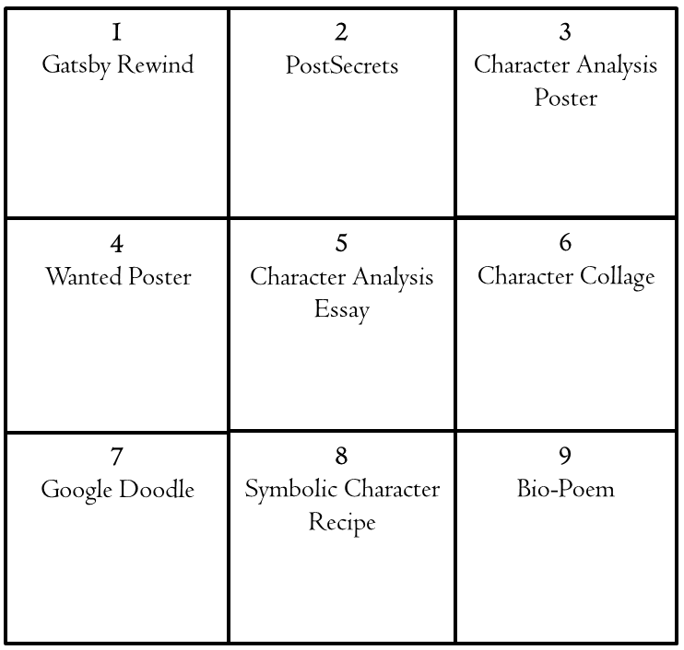
The Great Gatsby Tic-Tac-Toe Project Option Descriptions

- Rewinding Gatsby. At the end of the story, if a main character (either Gatsby, Nick, or Daisy) got a rewind button to use, what would he or she do with it? How would the story change if that character got to redo the story knowing the end? Respond in complete sentences, minimum of 250 words. Include at least 3 images that illustrate your response.
- PostSecrets. Create PostSecrets for 3 of these characters: Gatsby, Daisy, Nick, Tom, Myrtle, Jordan Baker, George Wilson. On the front, include a creative image (in color) and the secret. On the back, explain the secret in at least 75 words (Whose secret is it? Why do they keep it? and how does it affect them?). (See postsecret.com for real life examples.) Be original. Create a secret that they might have, rather than the obvious ones we already know about.
- Character analysis mini-poster (8x11 paper). Choose a character: Gatsby, Daisy, Nick, Tom, Myrtle, Jordan Baker, or George Wilson and…
- Find ONE example of direct characterization (The narrator or author tells you what the character is like), and ONE example of indirect characterization (The narrator or author shows you what the character is like, perhaps by the things s/he says & does.), and write these quotations on your poster as well as who is saying them.
- Infer what personality trait (kind, manipulative, honest, dishonest, greedy, power hungry, etc.) these quotations indicate about the character.
- Finally, illustrate the character by drawing him/her or something that symbolizes him/her.
- Create a wanted poster for a character in The Great Gatsby who has broken the law. Underneath the picture, write his/her name in large, bold letters. Include a paragraph (at LEAST 5 sentences) that thoroughly describes him/her and his/her crime(s).
- Character Analysis Essay. Write a 4-paragraph essay in which you analyze any character from The Great Gatsby.

- Include an introduction with a 2-point thesis statement (each point will be a character trait). 4 sentence minimum.
- Include 2 body paragraphs – topics are points in thesis. Each body paragraph must include an embedded quote to support the topic sentence. 4 sentence minimum
- Include a conclusion with a restated thesis statement. 3 sentence minimum.
- Character Collage. Using poster board, create a collage of one of the main characters (Gatsby, Daisy, Nick, Myrtle, Jordan, Tom). The pictures and shape of the poster should be relevant to the character. It should be no larger than ½ a poster board. Your poster board must be fully covered; you must have at least 25 images on the collage. (Note: a collage is not made of personally hand drawn images; you must find images that already exist for a collage.)
- Google Doodle. Using ½ a poster board, use the full title of the book to create a “Google Doodle.” Just like the search engine has art work behind/within the title of their logo, create a “doodle” that incorporates the title of the novel and is relevant to the novel itself.
- Symbolic Character Recipe. Create a symbolic recipe for 3 Gatsby characters. Include at least 5 ingredients and 3 steps for preparation. Follow recipe format for ingredients and method of preparation, but think symbolically (a cup of evil, not a pound of flesh). Determine what ingredients/characteristics are combined to make up the character you have chosen. Include the character’s name in the recipe’s title. You must then explain one or all 3 recipes (75 word minimum). Example for Elizabeth from The Crucible:

2 cups patience
1 heart full of love
½ cup of generosity
½ cup loyalty
1 cup understanding

First: Mix all ingredients well
Next: Sprinkle generously over a lifetime
Finally: Serve to everyone you meet

- Poetry: Write a ballad or Bio-Poem
- Ballad: Translate the book into a poem or song. Include main plot points. You need one stanza per chapter (total of 9 stanzas).

B) Bio-Poem Choose a character and analyze him/her in the form of a poem. Write a poem in the following format:
- Line 1. First name
- Line 2. 3 traits that describe character
- Line 3. Friend of ______
- Line 4. Lover of ______ (list 2 things or people)
- Line 5. Who feels _____ (2 items)
- Line 6. Who needs _____ (2 items)
- Line 7. Who fears _____ (2 items)
- Line 8. Who gives _____ (2 items)
- Line 9. Who would like to see _____ (2 items)
- Line 10. Resident of _____
- Line 11. Last Name or 1 word the character would use to describe him or herself.

