Creating an account in Turnitin.com
- Go to the CHS library Homepage. Click on Turnitin.com in the right hand column.
- Click create an account under the LOGIN box.
- Under Create a New Account, Click student.

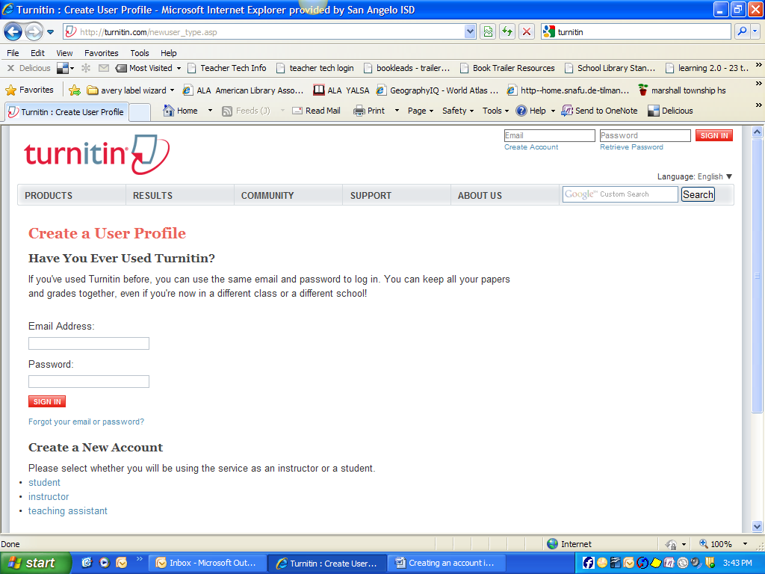

- Enter the class ID your teacher has given you. Each course and period has a unique id #.
- Enter your class password given to you by your teacher.
- Continue filling in the USER INFORMATION of First name, last name, and email.
- Create a password for Turnitin.com (consider your school computer password or facebook password so you can remember it). It needs to be 6-12 characters long and contain at least ONE letter and ONE Number. WRITE DOWN THE PASSWORD—you will need it again.
- Confirm you password.
- Then choose a secret question and answer.
- Read the user agreement with Turnitin.
- Click I am over 13 years old.
- Then click I agree. You have successfully created your Turnitin account!
SUBMITTING A PAPER To Turnitin
Once you have created your account, log in to your account in Turnitin.
- Click on the class name
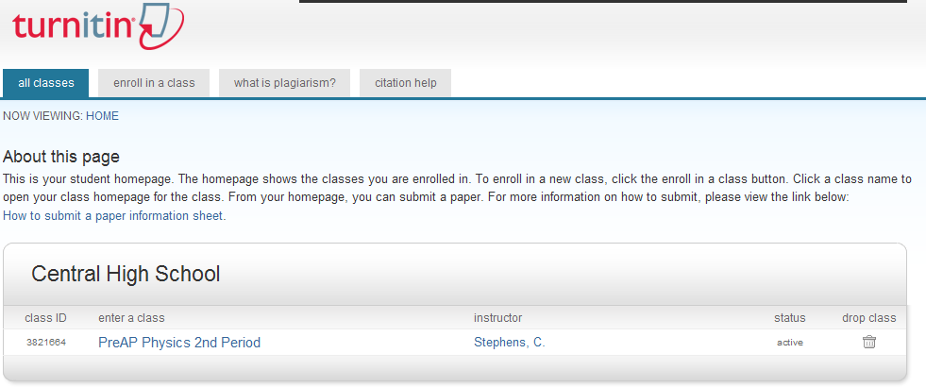

- Click Submit
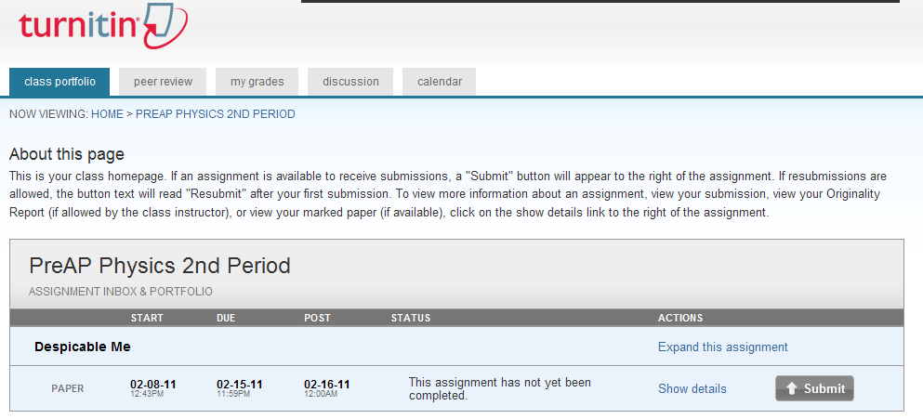

The default is Single File Upload to submit your paper.
- Click the BROWSE button and select the file you want to upload.
- Fill in the Submission Title with the paper’s name.
- Choose the file you wish to upload: from computer, from DropBox or From Google Drive
- Click Upload.
- Review the preview panel. CONFIRM that this is the correct version of the file. Click CONFIRM.
- After your paper is submitted, CONGRATULATIONS your paper has been submitted. A copy is also sent to your email account. SAVE the Email as proof that your paper was submitted.

