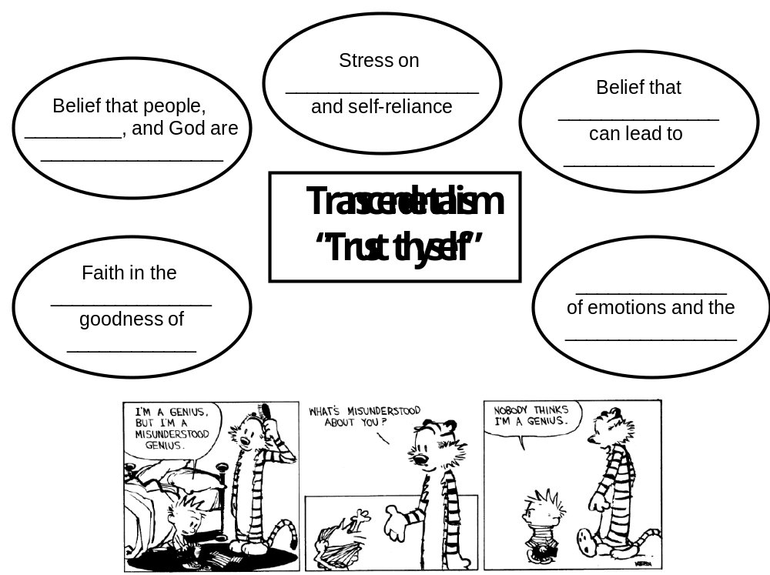

- an intellectual movement that emphasized the __________________ of the __________________ and advocated a __________________, mindful life.
- The transcendentalists wanted to transcend – or __________________– the limitations of the senses and everyday experience.
- Transcendentalists believed in disregarding external __________________ in __________________ of one’s own __________________ and intuition.
- “transcendent forms” of __________________ exist beyond __________________ and experience; every individual is capable of discovering this truth on his or her own, through __________________
- people are inherently __________________ and should follow their own __________________, however __________________ they may be
- special emphasis on __________________ with uncorrupted __________________

Transcendentalism in Song

- Song title _________________________________ Artist ________________________
- Quote lines that are examples of transcendental thought or ideas. Explain.
  - Quote: __________________________________________________________________________________________________________________________________________
  - Explanation __________________________________________________________________________________________________________________________________________
  - Quote: _________________________________________________________________________________________________________________________________________
  - Explanation __________________________________________________________________________________________________________________________________________

- Song title _________________________________ Artist ________________________
- Quote lines that are examples of transcendental thought or ideas. Explain.
  - Quote: __________________________________________________________________________________________________________________________________________
  - Explanation __________________________________________________________________________________________________________________________________________
  - Quote: _________________________________________________________________________________________________________________________________________
  - Explanation __________________________________________________________________________________________________________________________________________
FIND YOUR OWN SONG…
- Song title _________________________________ Artist ________________________
- Quote lines that are examples of transcendental thought or ideas. Explain.
  - Quote: __________________________________________________________________________________________________________________________________________
  - Explanation __________________________________________________________________________________________________________________________________________

