C:\Documents and Settings\110712\Local Settings\Temporary Internet Files\Content.IE5\RVQT1BNB\MC900358807[1].wmfThe Great Gatsby

By F. Scott Fitzgerald

C Level: Reading, Assignments, Quizzes, a Project

* Read assigned chapters
* Complete assignments & quizzes by due dates
* Achieve a 70% or higher on all handouts & quizzes
* Complete a project from the Gatsby Project Menu by assigned due date. This project may be done with a partner.
* Achieve 70% or higher on your project
* 2 Major grades of 75%

B Level: Reading, Assignments, Quizzes, and 2 Projects

* Read assigned chapters
* Complete assignments & quizzes by due dates
* Achieve an 80% or higher on all handouts & quizzes
* Complete 2 projects from the Gatsby Project Menu by assigned due date. One project may be done with a partner.
* Achieve 80% or higher on both projects
* 2 Major grades of 85%

A Level: Reading, Assignments, Quizzes, and 3 Projects

* Read assigned chapters
* Complete assignments & quizzes by due dates
* Achieve a 90% or higher on all handouts & quizzes
* Complete 3 projects from the Gatsby Project Menu by assigned due date. One project may be done with a partner.
* Achieve 90% or higher on your projects
* 2 Major grades of 95%

-These assignments are in addition to journal entries, vocabulary tests, and classroom participation.

-Minimal class time will be given to work on projects. That time will come when you finish the readings, quizzes, etc. Be aware that the majority of your work will be completed on your own.

***The Great Gatsby* Envelope Activity**

* You will be given 2 topics.
* While reading *The Great Gatsby*, you will copy (legibly, in neat writing) quotes, excerpts, &/or passages onto strips of paper or index cards and put them in that topic’s envelope.
* You will have the opportunity to meet with others and share your findings.
* Contents of the envelopes may be used to complete a Gatsby Project.
* Below are all envelope topics. Not all will be covered in your class period.

**Envelope 1**:  Fitzgerald explores the **repercussions of wealth** in the novel. Look for quotes that demonstrate ideas about **riches, materialism, people, and the American dream**. These passages should be both positive and negative as in the opportunities afforded to the wealthy as well as the carelessness of the wealthy.

**Envelope 2:**The presence of the past is significant in the novel. **Every character’s past defines them** no matter how hard they try to deny it or no matter how much they try to reclaim it. Can the past be repeated? Look for passages that represent this thematic question.

**Envelope 3:** What is Fitzgerald saying about **human hopes and dreams**? Find and think about significant passages dealing with this idea.

**Envelope 4:**  Eyes are seen throughout this novel. Look for passages that refer to **eyes, description of eyes, and what people see through their (or others’) eyes**.

**Envelope 5:** Shakespeare once said (I am paraphrasing) that the only way a secret can be kept between two people is if one of them is dead. Yet the characters in this novel are quite good at keeping secrets. Look for passages and quotes that capture the **true essence of secrets and the power that lies within them**.

**Envelope 6:** Corruptionis a common theme in the novel and during the 1920’s in the United States. Trace passages that reflect the **levels of corruption** in the novel – from Jordan’s sportsmanship to Gatsby’s business affairs and associates.

**Envelope 7:** Time ….. Sources say that there are over 400 references to time in the novel and approximately 85 uses of the word “time” itself. Although your envelope certainly does not have to contain all of them, look for **passages about time or that contain the word “time.”** Think about what this repetition of time illustrates about possible themes in Gatsby.

**Envelope 8:**Fitzgerald was considered a spokesman for his generation when he wrote this novel of life in the 1920’s. Look for significant passages/ quotes that address the **morality of the people** he saw as representative of his time.

**Envelope 9:** Look for quotes and passages that **illuminate the narrator’s perspective**, which is complex in this novel. Nick Carraway is an active participant in the story as well as an observer and reporter of it.

**Envelope 10:**Fitzgerald and his narrator reference the **role of judgment and conscience** in human nature. Look for passages with these references that help define this idea within the novel.

**Envelope 11:**  Colors are a motif in the novel, particularly **green, white, silver and gold**. Look for passages with color references. Think about the symbolism of the colors as you analyze the passages.

**Envelope 12:**  Ashes, fire and dust are recurring motifs in the novel. Look for passages that reference **ashes, fire and dust** in any form from candlelight flames to heaps of ashes.

**Envelope 13:** In this novel, socio economic / social status is not necessarily constant for all characters. Look for passages that reflect the fluidity amongst the classes **(change from one social status level to another)** of the characters. Be sure to note the character and what change is occurring.

**Envelope 14:** Geography is a motif in the novel. Look for **passages that reference geographical locations** including East and West Egg but also other places like Louisville, Kentucky and the Midwestern part of the United States.

**Envelope 15:** Images of violence are recurring throughout the novel. Track passages that reference **acts of violence**. Think about the role of violence not just as plot advancement but as characterization of those who are the victims and perpetrators.

**Envelope 16:** The vision of American culture is conveyed through the speaker's ambivalent attitude toward the automobile and its owner in this novel. Look for **passages that reference cars, both riding in and driving cars, road trips**. What message does the tone of these passages convey?

***The Great Gatsby* Character Chart. As you read, note the good ☺and bad ☹qualities for each character.**

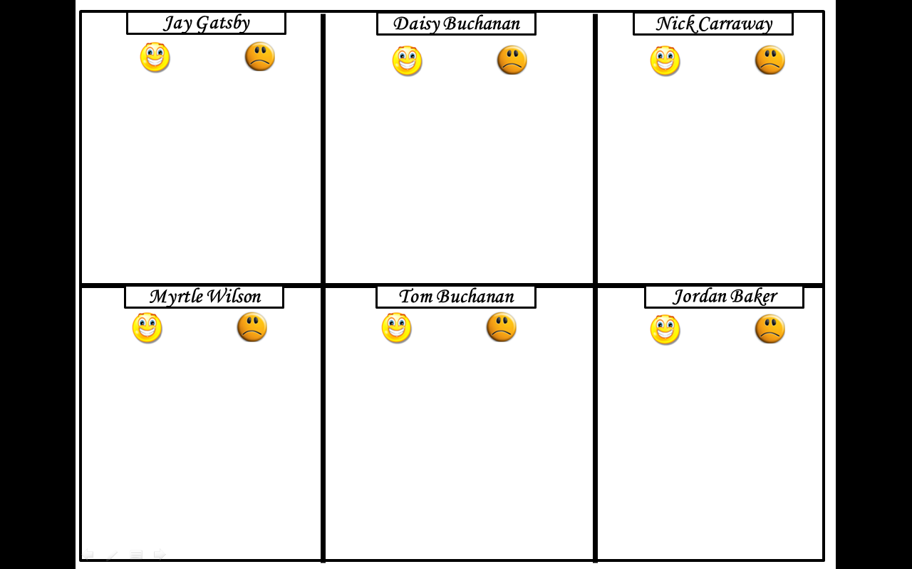

*The Great Gatsby*: Symbolism

**Colors**

White Represents:

* Façade behind which characters hide
* beauty, cleanliness, wealth, innocence, virginity and laziness

**Examples**

* _________________________
* _________________________
* _________________________
* _________________________
* _________________________
* _________________________

Yellow (Silver & Gold) Represents: Wealth, corruption, dishonesty. **Examples:**

* _________________________
* _________________________
* _________________________
* _________________________
* _________________________
* _________________________

Green Represents: Hope, rebirth, to “go”, youth, longing, choice, serenity. **Examples:**

* _________________________
* _________________________
* _________________________
* _________________________
* _________________________
* _________________________

Blue Represents: Heaven, fantasy, lost time, unhappiness. **Examples:**

* _________________________
* _________________________
* _________________________
* _________________________
* _________________________
* _________________________

Grey Represents: Industrialization, dreary, bleak, lifeless. **Example:** _____________________

Red Represents: Death, abuse, violence, destruction. **Examples:**

* _________________________
* _________________________
* _________________________
* _________________________
* _________________________
* _________________________

Water

Represents:

* Barriers and boundaries
* Gatsby’s restraints from Daisy
* Abandonment

**Water Examples:**

* _________________________
* _________________________
* _________________________
* _________________________
* _________________________
* _________________________

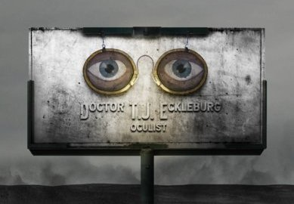

Eyes Represent: Observant, omnipresent, watchful, non-judgmental. **Examples:**

* _________________________
* _________________________
* _________________________
* _________________________
* _________________________
* _________________________

Cars Represent: Industrialization, status symbol, carelessness, recklessness

**Examples:**

* _________________________
* _________________________
* _________________________
* _________________________
* _________________________
* _________________________

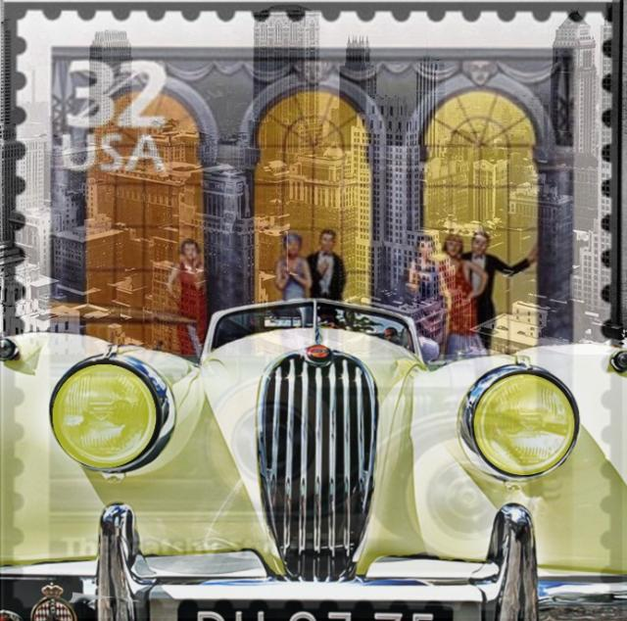

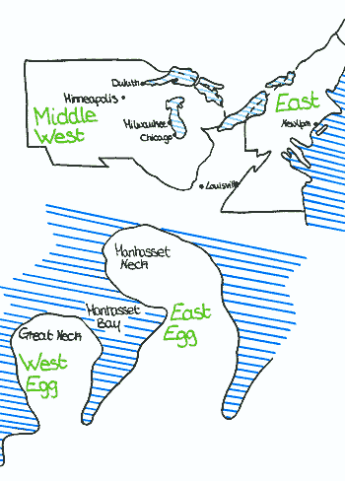

Eggs   
(also: White covered by yellow)

Represent: Pure façade, while rotten inside

**Examples:**

* _________________________
* _________________________
* _________________________
* _________________________
* _________________________
* _________________________

***The Great Gatsby.* Chapter 1. Questions**

1. Notice how many times Fitzgerald uses the words hope, or dream. Why does he do

this?______________________________________________________________________

__________________________________________________________________________

1. Nick starts the novel by relaying his father's advice "Whenever you feel like criticizing

anyone, just remember that all the people in this world haven't had the advantages that

you've had." List Nick's advantages.

__________________________________________________________________________

__________________________________________________________________________

1. Pay attention to time. What is the day and year during the first scene at Daisy's house?

__________________________________________________________________________

__________________________________________________________________________

1. Describe Nick. What facts do you know about him, and what do you infer about him? What kind of a narrator do you think he will be?

__________________________________________________________________________

__________________________________________________________________________

1. What image does the author use to describe Jordan Baker? What does it mean?

__________________________________________________________________________

__________________________________________________________________________

1. How does Nick react to Jordan?

__________________________________________________________________________

__________________________________________________________________________

1. What does Tom's behavior reveal about his character?

__________________________________________________________________________

__________________________________________________________________________

* **Quotes: Write down a quote, the page, and why it is important to this chapter. (page _____):** “_________________________________________________________________________________________________________________________________________________________________________________________________________________________________________________”
* **Why it’s important:**

________________________________________________________________________________

________________________________________________________________________________

* **Give this chapter a title.**

________________________________________________________________________________

* **Why did you give it this title?**

________________________________________________________________________________

________________________________________________________________________________